1. 绘制路网.net.xml文件

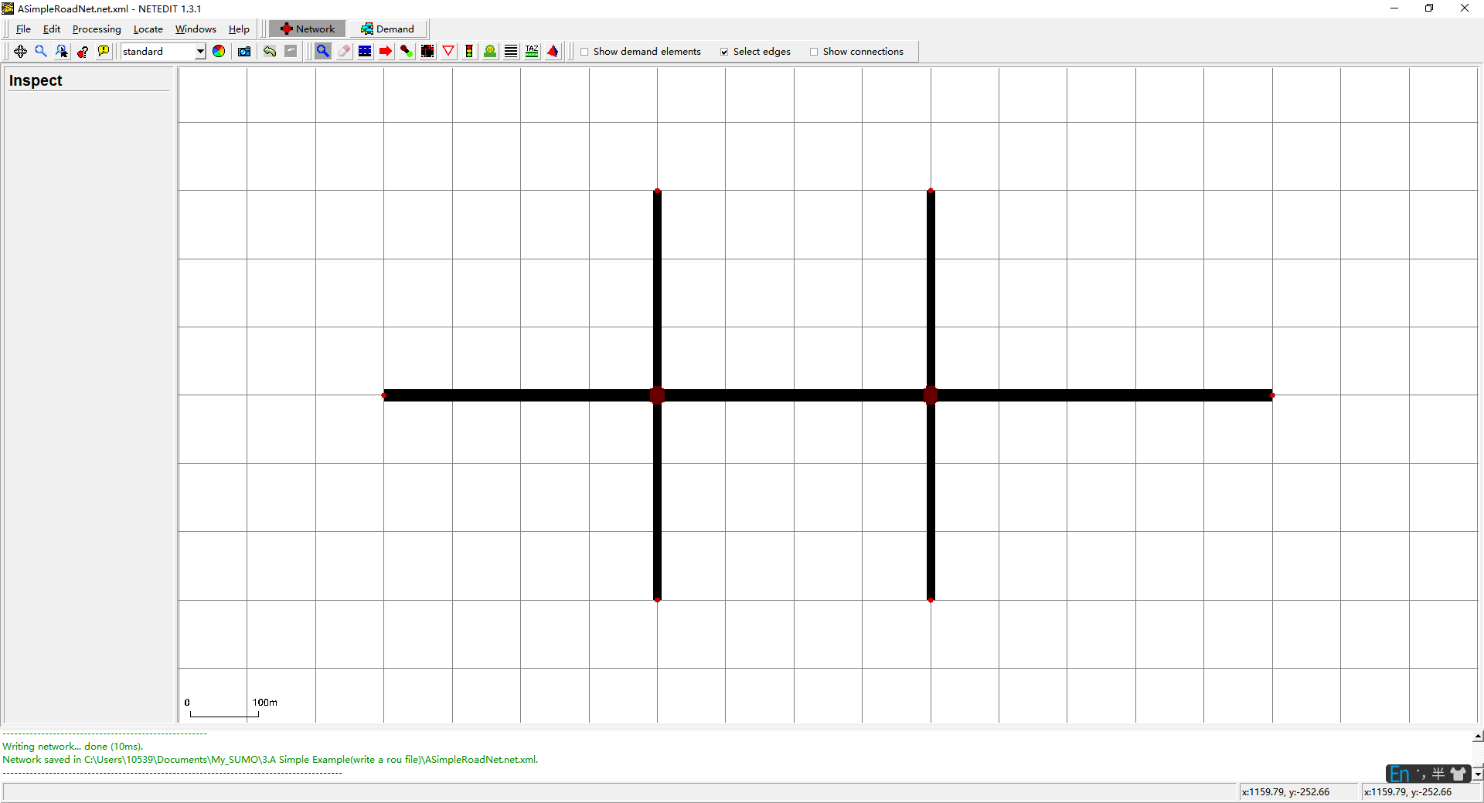

1. 构造.sumocfg文件

<input>

    <net-file value="ASimpleRoadNet.net.xml"/>

    <route-files value="ASimpleRoadNet.rou.xml"/>

    <additional-files value="signal_config1.xml;signal_config2.xml"/>

</input>

<time>

    <begin value="0"/>

    <end value="3600"/>

</time>

1. 构造.flows.xml文件

<flowdefs>

    <interval begin="0" end="3600">

        <flow id="0" from="gneE0" to="gneE12" number="150" />

        <flow id="1" from="gneE3" to="gneE12" number="180" />

        <flow id="2" from="gneE11" to="gneE1" number="100" />

        <flow id="3" from="gneE13" to="gneE2" number="100" />

        <flow id="4" from="gneE9" to="gneE2" number="100" />

        <flow id="5" from="gneE7"  to="gneE10" number="100" />

    </interval>

</flowdefs>

1. 构造.duarcfg文件

<configuration xmlns:xsi="http://www.w3.org/2001/XMLSchema-instance" xsi:noNamespaceSchemaLocation="http://sumo.dlr.de/xsd/duarouterConfiguration.xsd">

    <input>

        <net-file value="ASimpleRoadNet.net.xml"/>

        <route-files value="ASimpleRoadNet.flows.xml"/>

    </input>

    <output>

        <write-license value="true"/>

        <output-file value="ASimpleRoadNet.rou.xml"/>

    </output>

    <report>

        <no-step-log value="true"/>

    </report>

</configuration>

1. 运行duarouter生成rou.xml

call="%SUMO_HOME%bin\duarouter" -c  test.duarcfg